**Alekhya Krishna Balivada Python Coding Assessment (20-12-2023)**

1. **Explain Python Module with examples  
   a.Import module in Python  
   b.Renaming the Python module**

**Ans:**

**Module:** A module is like a file with code where we can perform the specific task. User-defined python modules are the modules which are created by the user to perform the tasks. A module may contain functions, classes, variables and so on.

1. **Import module in python**

* We can import the module in python by using ‘import’ keyword.
* We can perform various operations by importing the modules.
* When we import module in python first it will search for the module in the local modules then it will perform the operations.

For example we can import as user-defined or built-in

* User defined modules can be imported by creating a file with .py extension and importing the module

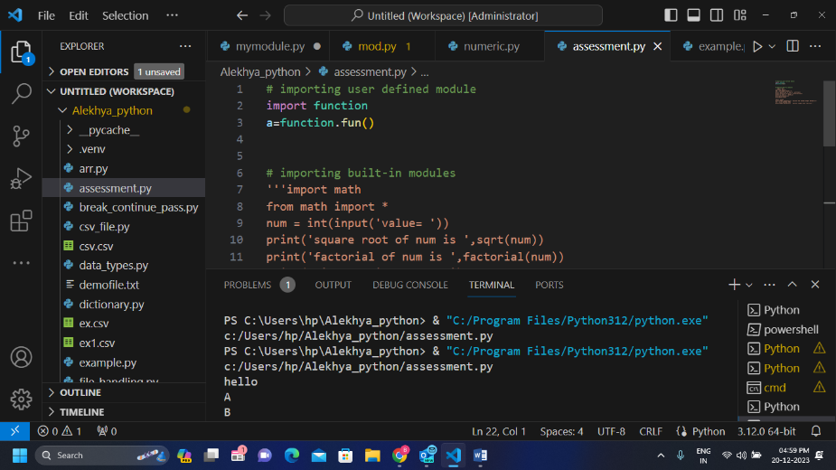Ex: create a file as function.py and then import the function to do the operations

* Built-in modules can be imported by importing them like -
* import math to perform the math functions
* 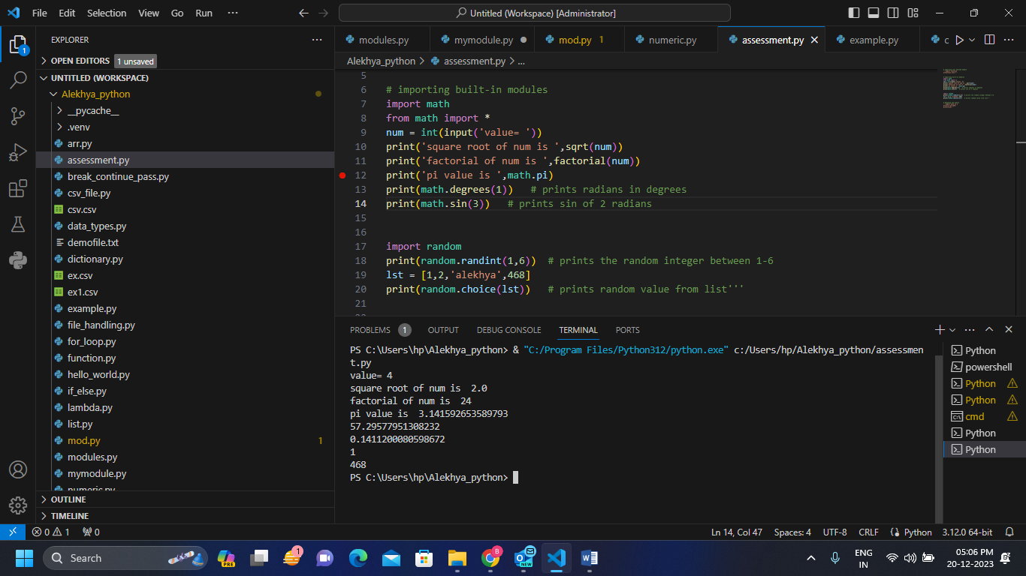import random to print random outputs

1. **Renaming the python module**

* We can rename the python module by using ‘**as**’ keyword.

**Ex – import math as m**

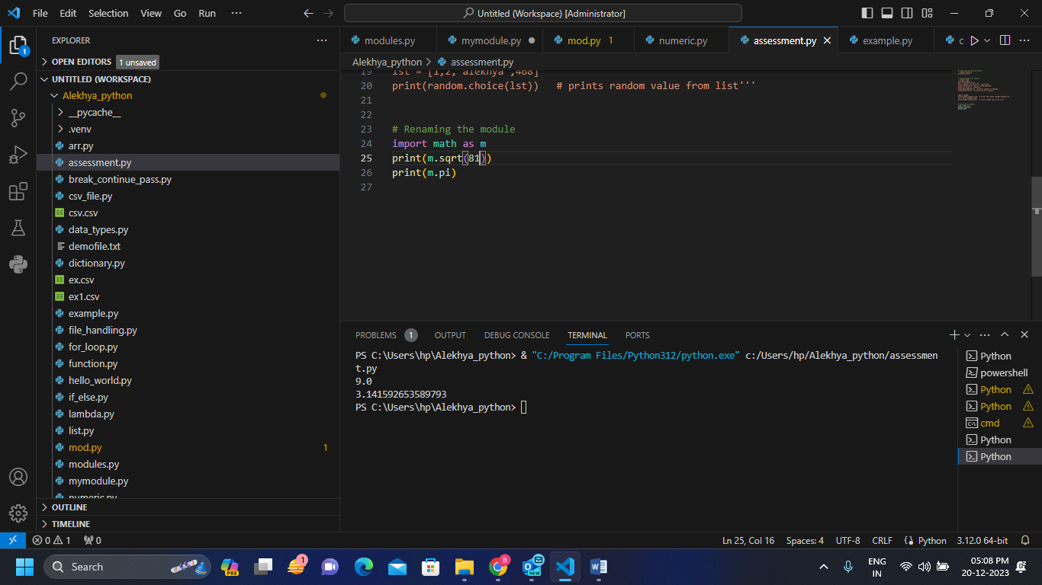

**Code:**

# importing user defined module

import function

a=function.fun()

# importing built-in modules

import math

from math import *

num = int(input('value= '))

print('square root of num is ',sqrt(num))

print('factorial of num is ',factorial(num))

print('pi value is ',math.pi)

print(math.degrees(1))   # prints radians in degrees

print(math.sin(3))   # prints sin of 2 radians

import random

print(random.randint(1,6))  # prints the random integer between 1-6

lst = [1,2,'alekhya',468]

print(random.choice(lst))   # prints random value from list

# Renaming the module

import math as m

print(m.sqrt(81))

print(m.pi)

1. **Explain Pandas and numpy using Examples in PYTHON**

**Ans:**

**Pandas**: Pandas is a data manipulation package in Python for tabular data. That is, data in the form of rows and columns, also known as Data Frames.

* To import pandas first we need to install the pandas package in python
* We can install pandas by the command ‘pip install pandas' in command prompt.
* First we need to create the txt file data with commas like
* Name,Age,Company,City
* Alekhya,21,Hexaware,Chennai
* Vandana,22,TCS,Gujarat
* Jahnavi,25,TechM,Hyderabad
* Charan,38,NCS,Odissa
* Manoj,30,Wipro,Bangalore
* Dileep,32,Cognizant,Hyderabad
* Pranneth,45,Electrics Ltd,Mumbai
* Then we can read the file data in the form of tables as by using read_csv command.

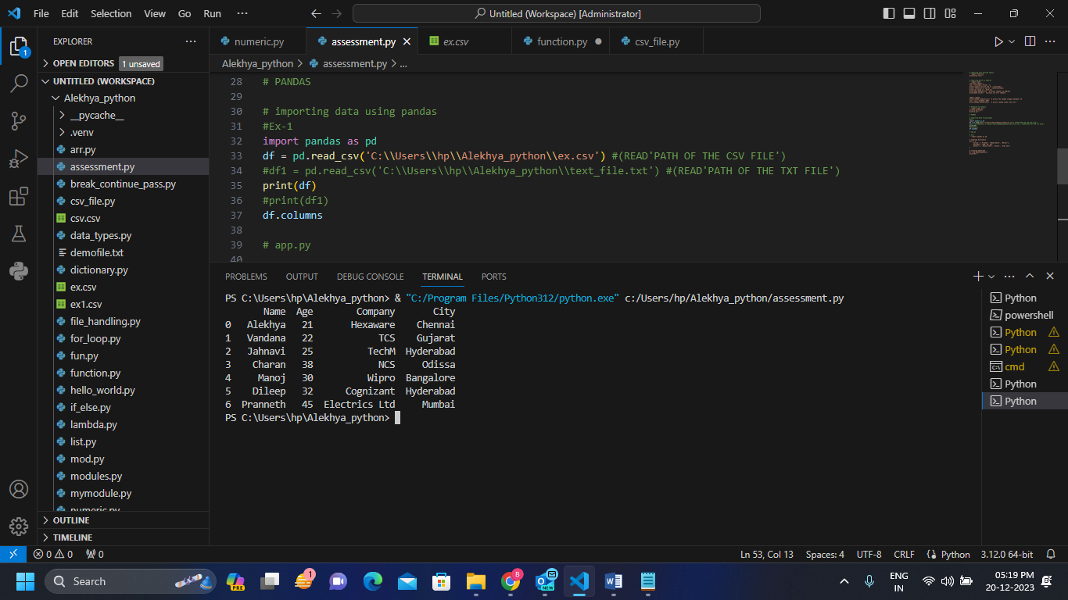

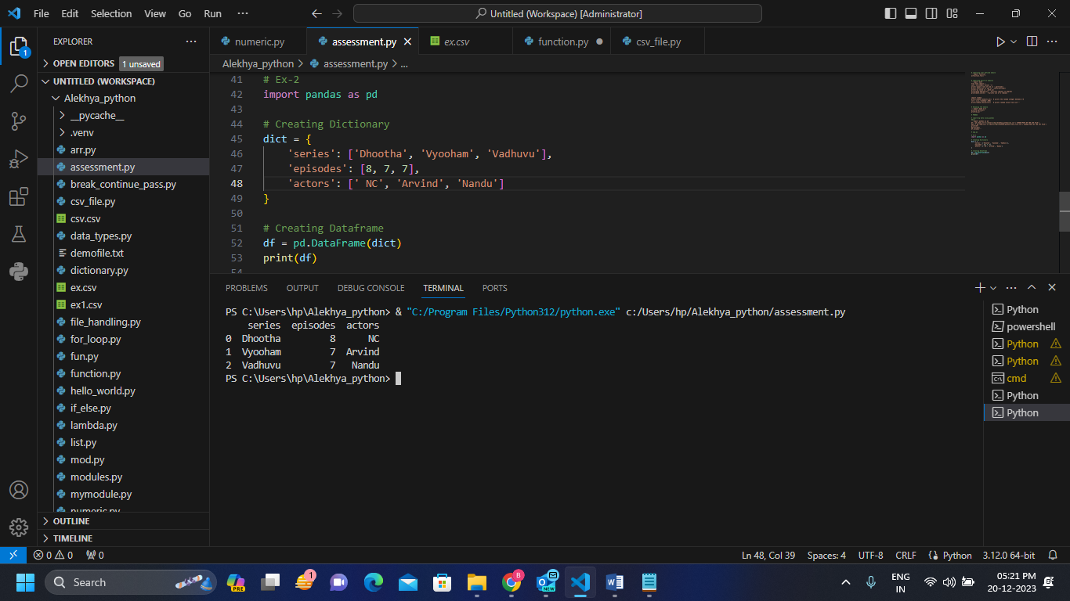

**Code:**

# PANDAS

# importing data using pandas

#Ex-1

import pandas as pd

df = pd.read_csv('C:\\Users\\hp\\Alekhya_python\\ex.csv') #(READ'PATH OF THE CSV FILE')

#df1 = pd.read_csv('C:\\Users\\hp\\Alekhya_python\\text_file.txt') #(READ'PATH OF THE TXT FILE')

print(df)

#print(df1)

df.columns

# app.py

# Ex-2

import pandas as pd

# Creating Dictionary

dict = {

    'series': ['Dhootha', 'Vyooham', 'Vadhuvu'],

    'episodes': [8, 7, 7],

    'actors': [' NC', 'Arvind', 'Nandu']

}

# Creating Dataframe

df = pd.DataFrame(dict)

print(df)

**Numpy:** NumPy (**Numerical Python**) is an open source Python library .

* To import numpy first we need to install the pandas package in python
* We can install pandas by the command ‘pip install pandas' in command prompt.

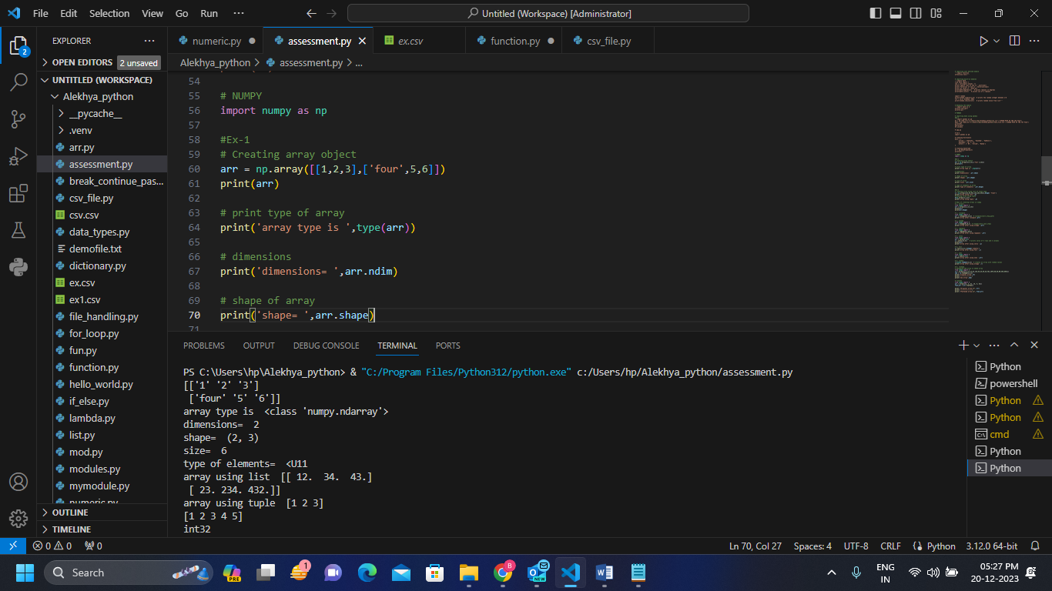

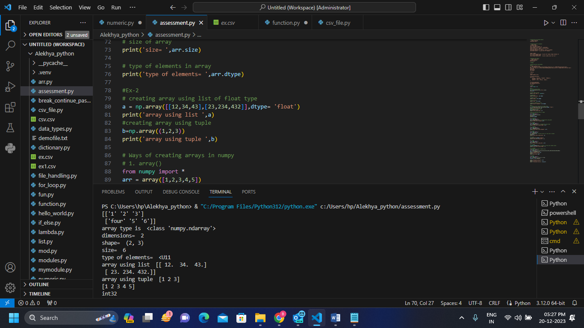

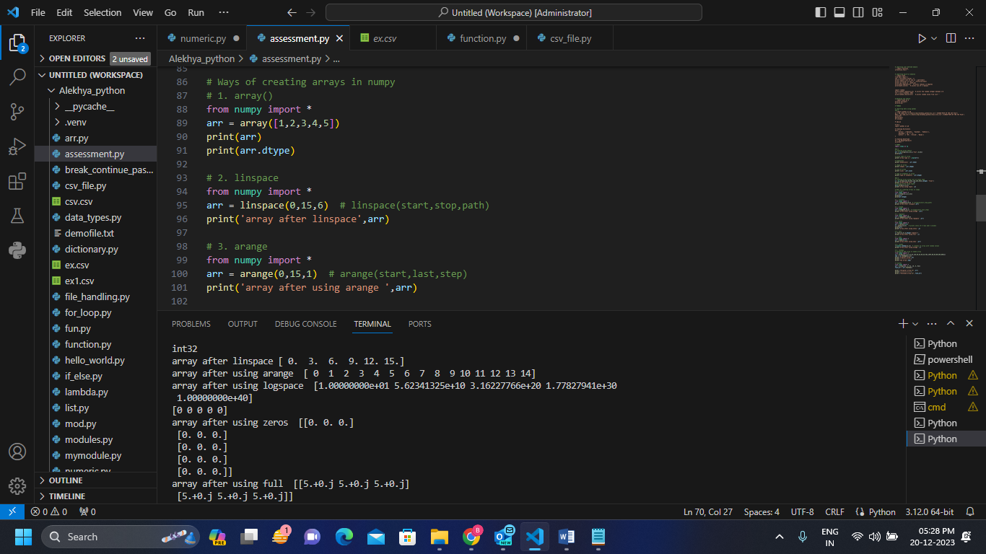

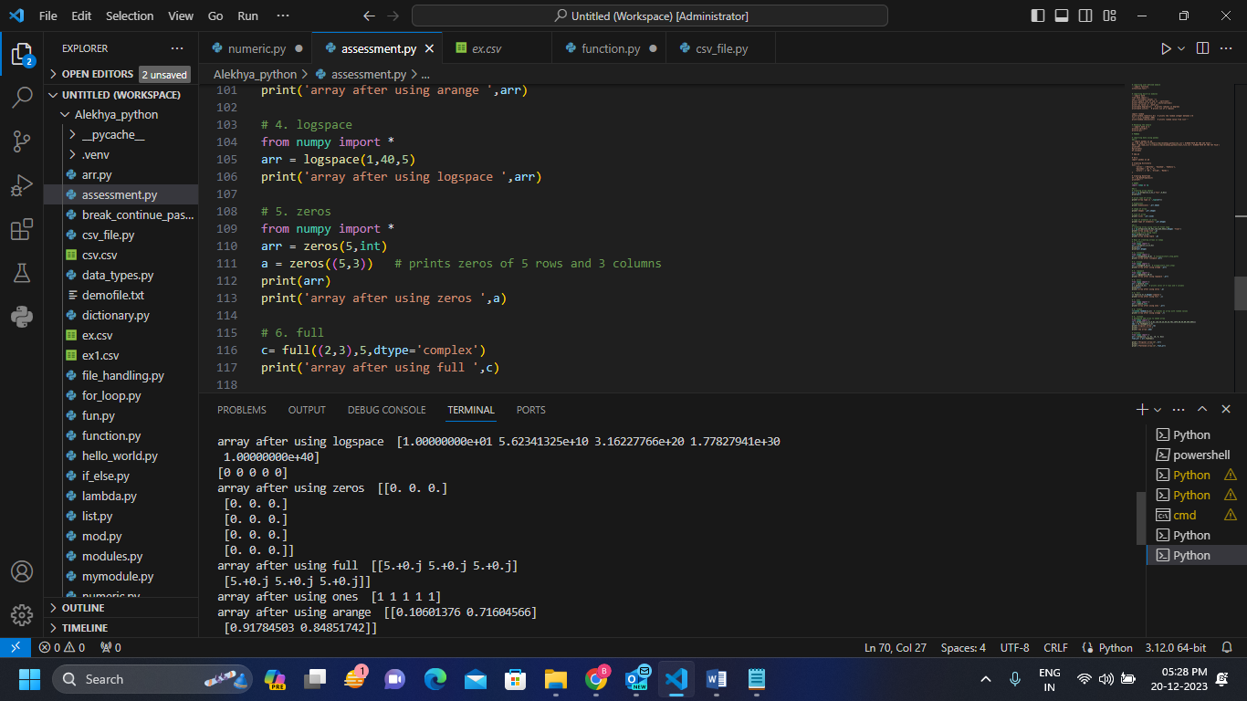

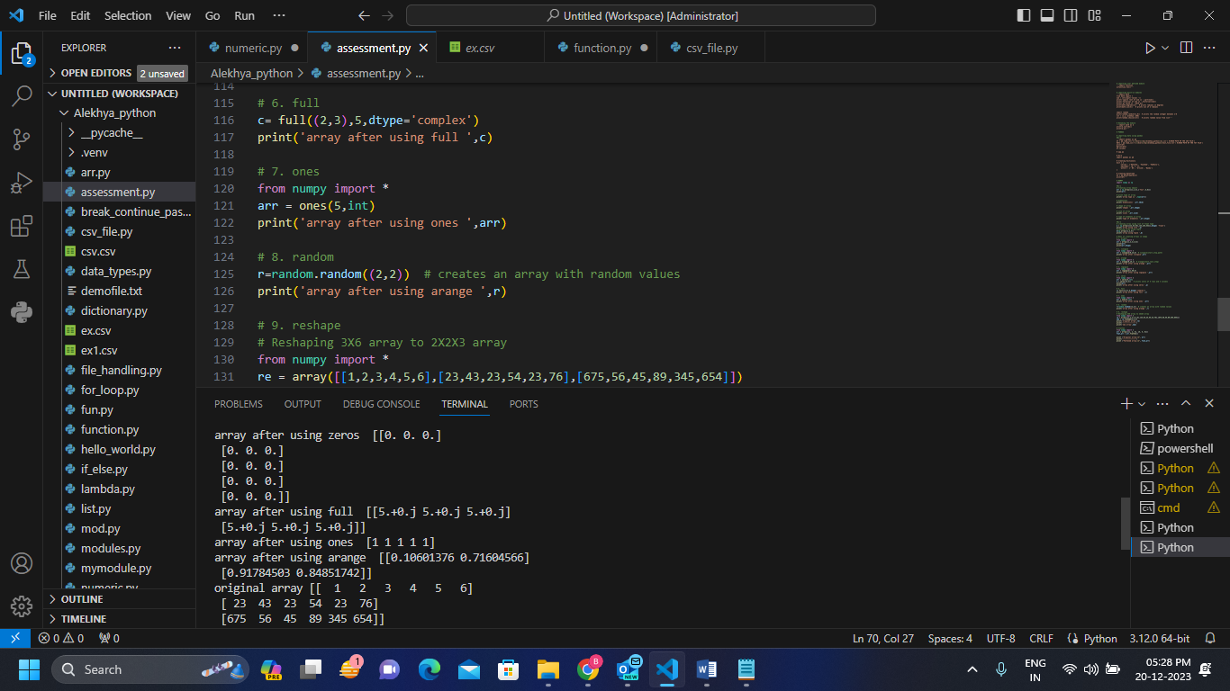

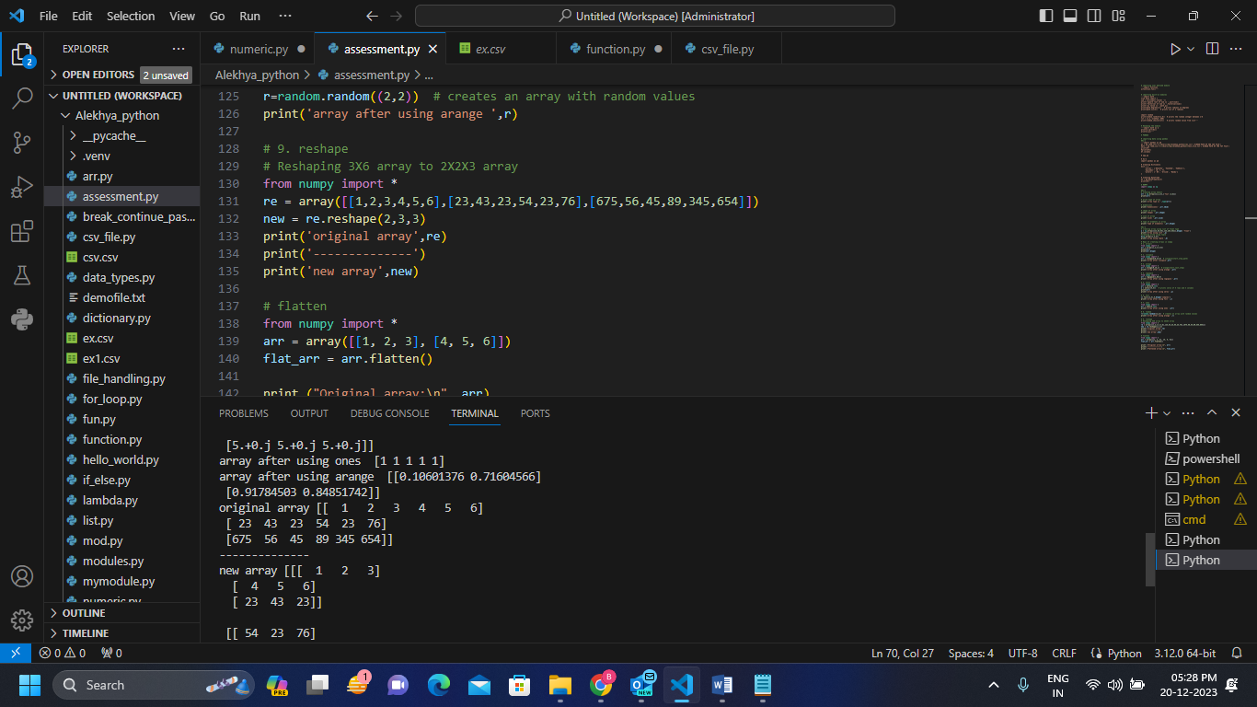

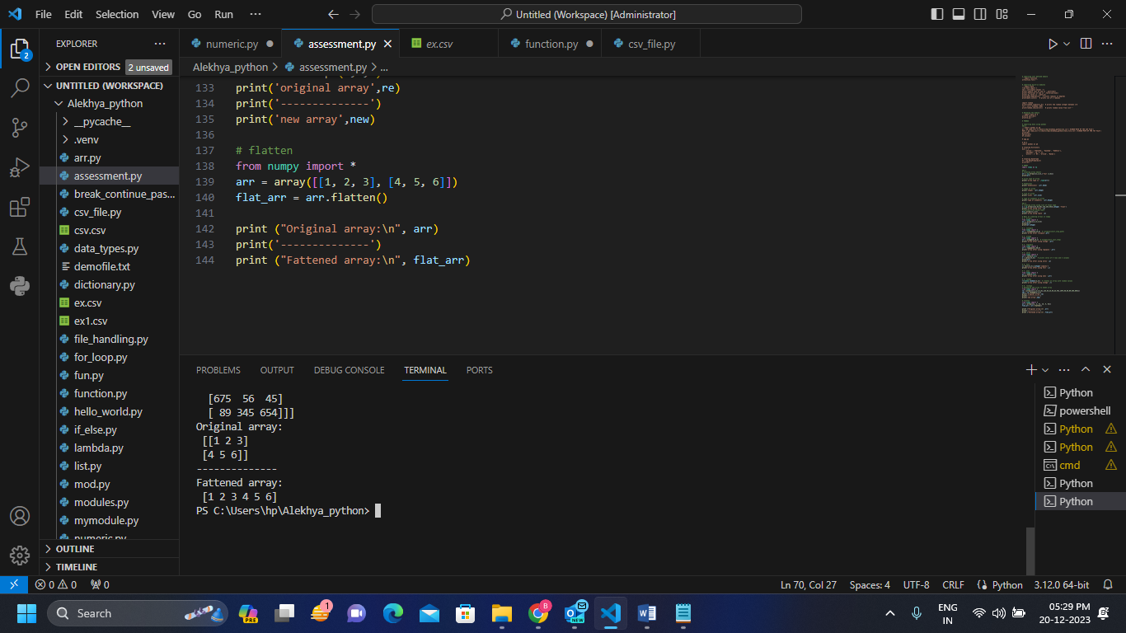

**Code:**

# NUMPY

import numpy as np

#Ex-1

# Creating array object

arr = np.array([[1,2,3],['four',5,6]])

print(arr)

# print type of array

print('array type is ',type(arr))

# dimensions

print('dimensions= ',arr.ndim)

# shape of array

print('shape= ',arr.shape)

# size of array

print('size= ',arr.size)

# type of elements in array

print('type of elements= ',arr.dtype)

#Ex-2

# creating array using list of float type

a = np.array([[12,34,43],[23,234,432]],dtype= 'float')

print('array using list ',a)

#creating array using tuple

b=np.array((1,2,3))

print('array using tuple ',b)

# Ways of creating arrays in numpy

# 1. array()

from numpy import *

arr = array([1,2,3,4,5])

print(arr)

print(arr.dtype)

# 2. linspace

from numpy import *

arr = linspace(0,15,6)  # linspace(start,stop,path)

print('array after linspace',arr)

# 3. arange

from numpy import *

arr = arange(0,15,1)  # arange(start,last,step)

print('array after using arange ',arr)

# 4. logspace

from numpy import *

arr = logspace(1,40,5)

print('array after using logspace ',arr)

# 5. zeros

from numpy import *

arr = zeros(5,int)

a = zeros((5,3))   # prints zeros of 5 rows and 3 columns

print(arr)

print('array after using zeros ',a)

# 6. full

c= full((2,3),5,dtype='complex')

print('array after using full ',c)

# 7. ones

from numpy import *

arr = ones(5,int)

print('array after using ones ',arr)

# 8. random

r=random.random((2,2))  # creates an array with random values

print('array after using arange ',r)

# 9. reshape

# Reshaping 3X6 array to 2X2X3 array

from numpy import *

re = array([[1,2,3,4,5,6],[23,43,23,54,23,76],[675,56,45,89,345,654]])

new = re.reshape(2,3,3)

print('original array',re)

print('--------------')

print('new array',new)

# flatten

from numpy import *

arr = array([[1, 2, 3], [4, 5, 6]])

flat_arr = arr.flatten()

print ("Original array:\n", arr)

print('--------------')

print ("Fattened array:\n", flat_arr